Figure 1: Median (Q1, Q3) ALT(U/L) by Treatment and Visit Safety

Analysis Set

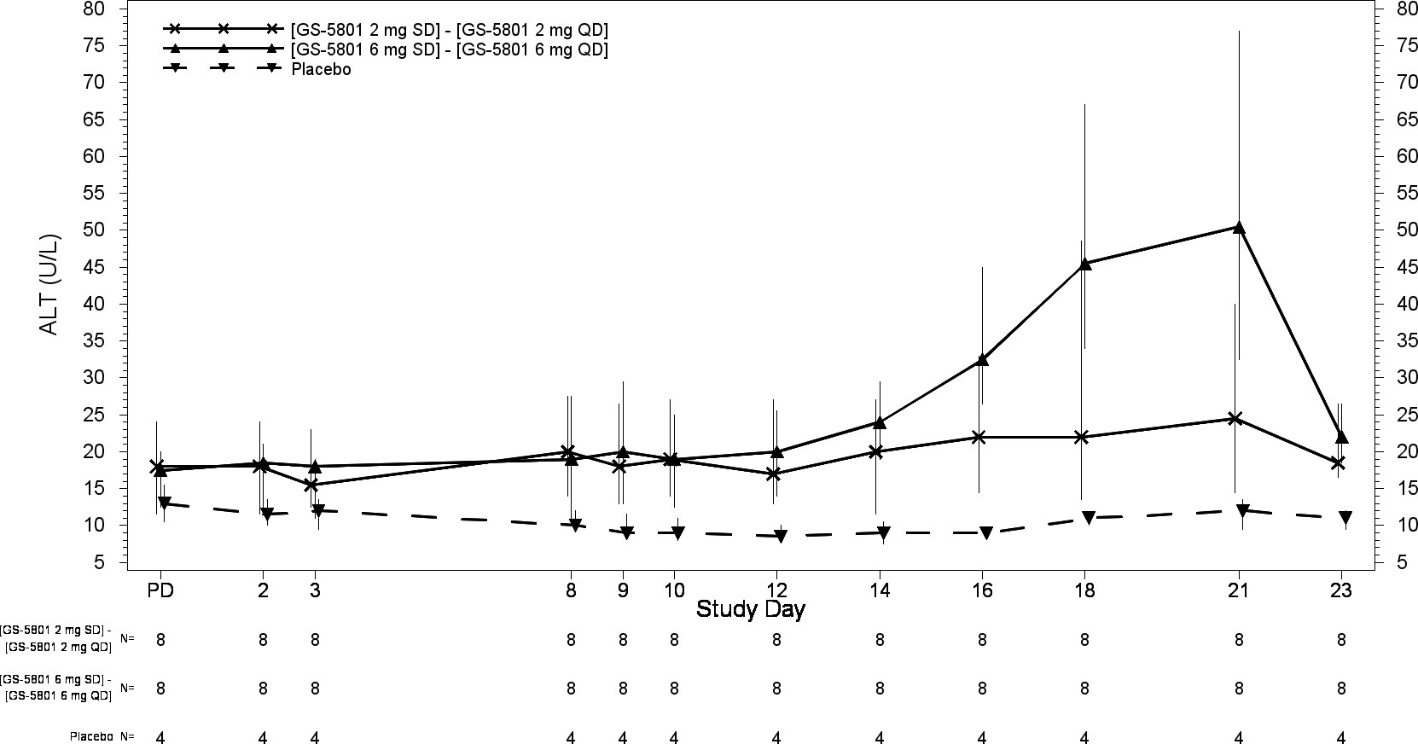

**[GS-XXXX 20 mg SD] – [GS-XXXX 20 mg QD] [GS-XXXX 60 mg SD] –**

**[GS-XXXX 60 mg QD]**

**Placebo**

**[GS-XXXX 20 mg SD] – [GS-XXXX 20 mg QD] [GS-XXXX 60 mg SD] – [GS-XXXX 60 mg QD]**

**Placebo**

Predose value was the last available value collected on or prior to first dose of study drug. PD = Predose

Gilead Sciences, Inc.

GS-US-XXX-XXXX

Data Extracted: CRF data: XXXXXXXXX

Source: ...\Version 1\Figures\g-alt.sas, v9.4, XXXXXXXXX: X:XX Page 1 of 1